Title Manuscrip (Title 8-15 words, Capital Each Word (Except Conjunctions), Cambria font size 14)

First Author^{1*}, Second Author², Third Author³, etc
¹Institution of First Author
² Institution of Second Author
³ Institution of Third Author
*Correspondence Email
ARTICLE INFO |  | ABSTRACT
Article History  Received :  Accepted :  Published online :  Keywords:  arranged by alphabetically and contain three to five words/phrases separated with coma.  Kata Kunci:  disusun berdasarkan alphabet, terdiri dari 3 sampai dengan 5 kata kunci yang dipisahkan dengan koma. |  | The abstract is made in 1 whole paragraph in English. Abstract writing of a maximum of 250 words containing the scope of the research carried out by emphasizing preliminary data from general to specific data, using 10 points Cambria font, spaced 1. The abstract contains the introduction, namely the background of why the research needs to be researched (1-2 sentences), research objectives that are described briefly, concisely, and clearly (1 sentence), materials and methods, including research design, sample size, data collection techniques, and research time and analysis techniques used (3 -5 sentences), research results/findings (3-5 sentences), conclusions, containing the implications of the findings/results which are explained briefly and containing suggestions (1 sentence)
 |  | ABSTRAK
 |  | Penulisan abstrak maksimal 250 kata yang berisi ruang lingkup penelitian yang dilakukan dengan menekankan data awal dari data yang bersifat umum ke data yang bersifat khusus, menggunakan huruf Cambria ukuran 10 poin, spasi 1. Abstrak berisi pendahuluan, yaitu latar belakang mengapa penelitian tersebut perlu diteliti (1-2 kalimat), tujuan penelitian yang diuraikan secara singkat, padat, dan jelas (1 kalimat), bahan dan metode, meliputi desain penelitian, besar sampel, teknik pengumpulan data, dan waktu penelitian serta teknik analisis yang digunakan (3-5 kalimat), hasil/temuan penelitian (3-5 kalimat), kesimpulan, berisi implikasi dari temuan/hasil penelitian yang diuraikan secara ringkas dan berisi saran (1 kalimat)

INTRODUCTION

The introduction contains the urgency and background of the research problem described by the inverted pyramid method starting from the global, national and local levels. The number of pages in the introduction is 1-1.5 pages written using Cambria 11 points (upright) with 1.0 spacing. The final section of the introduction should state the purpose of the research.

MATERIAL AND METHOD

This section describes the type of research, the location and time of the study, the population and sample, sampling techniques, data collection techniques, data analysis, and data presentation. Research that uses tools and materials needs to write down the specifications of the tools and materials used. Qualitative research such as case studies, phenomenology, ethnography, and others, need to add a description of checking the validity of research results. The writing using Cambria 11 points (upright) with 1.0 spacing. Paragraphs begin with words indented into five digits and this section is shown in 1-2 paragraphs.

RESULTS

The results contain the research output by describing the factual and valid findings, objectives, and research methods. The results section describes the characteristics of the research subjects, univariate analysis, bivariate analysis and multivariate analysis (if any). An example of writing statistical results is the results of the study showing xxxxxxxxxxxxxx xxx (p = 0,000; OR = 45,25; 95% CI = 13,23 < OR < 154,72) against Z disease.

Format Tables, Mathematical Formulas, Diagrams, and Figure
The table title is placed above the table. Each table and figure must be numbered (e.g.: “Table 1”, “Figure 1”). Tables are typed one spaced and numbered sequentially according to their appearance in Cambria (Bold) letters font size 10. Writing tables do not use vertical lines but only horizontally. The maximum number of 5 tables and figure with short and complete titles.

The presentation of tables, figures, and formulas should not precede the narrative.
The writing in tables, diagrams, and figure uses Cambria Size 10 format except for descriptions of image sources and tables using Cambria Size 9.

Figure
The figure is placed after the narration of the figure. Images cannot be framed. The legend or description of the image is at the bottom or side of the image; it must not be above the image. The caption or title of the image is under the image in question using Cambria 10 point (Bold) format. Image resolution must be high so as not to break the image.
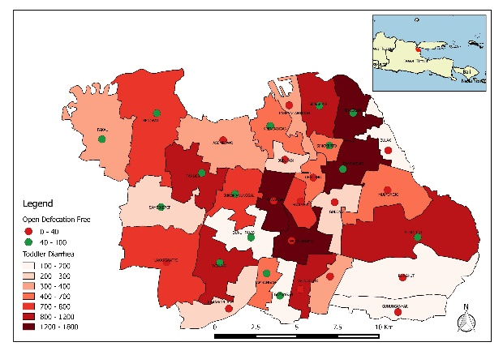Source: Dinas Kesehatan, 2020
Figure 1. Title of Figure (Capital letters at the beginning of words)

Diagram/Graphic
Making diagrams in the form of bar, line or circle charts, use two-dimensional diagrams without frames. The narration is placed before the diagram. The narration is not a repetition of the narrated diagram. The diagram's title is below the description or source of the relevant diagram using Cambrian 10 point (Bold) format. Diagram includes to the category of images. Xxxxxxxxxxxxxxxxxxxx (Figure 2).
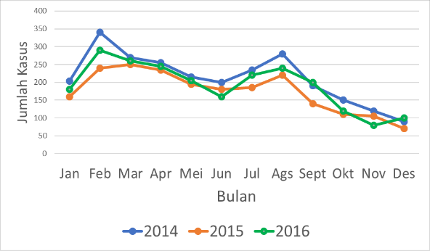
Source: Dinas Kesehatan, 2020
Figure 2. Title

Table
The writing of numbers is centered, for titles it is median, and information such as variables and sub-variables is left aligned. If there are > 2 variables in one variable, the titles of the different variables are in bold. The writing of the decimal number is two digits behind the comma.
Place the table narration before the table. Narrative is not a repetition of the narrated table but adapted to the purpose of the study. Example; Most of the respondents were aged 20–35 years (Table 1).
Tables should not be truncated on different pages. Table truncation is allowed if it exceeds one page provided that the table has started at the top and then is not sufficient to require additional space.
Writing sources in tables and figures is only intended for tables and figures that are sourced from other people, not from the results of their own research. If there are many variables studied in the table, a large table can be made. Long tables can be made in the form of one column as in the example Table 2.
The one-column table position must be at the top or bottom. (must not be in the middle of the page. If the picture/table requires a large and wide space or space, then a large picture can be made. Place the large picture at the very top or bottom of the page. It should not be placed in the middle of the page This is so that the reader is not confused in the order of reading.

Tabel 1. Title of Table (Capital Letters at the Beginning of Words, except for Prepositions and Connecting Words)
Characteristics | n= number of sample | %
Age (years)
< 20 | XX | XX.XX
21-30 | XX | XX.XX
31-40 | XX | XX.XX
Education
Low | XX | XX.XX
High | XX | XX.XX
Employment status
Yes | XX | XX.XX
No | XX | XX.XX
Etc.

DISCUSSION

The discussion contains interpretation of research results, linking research results with relevant theories, literature and previous findings. The discussion is not repeating the results. Aspirations of insight are universal, preferably sources on an international scale compared to national scale. Writing on the results and discussion ± 55% of the total page.

CONCLUSION AND RECOMMENDATION

Conclusions and recommendations contain a summary of the description of the results and discussion with reference to the research objectives. Suggestions are prepared based on the research findings that have been discussed. Suggestions may refer to practical action, the development of new theories, and/or further research. Writing conclusions and suggestions using Cambria 11 points (upright) with 1.0 spacing and may not use bullets or numbers. This section is displayed in 1-2 paragraph.

ACKNOWLEDGEMENTS (OPTIONAL)

Acknowledgments can be given to 1) the parties to provide financial assistance and support, 2) the support of sections and institutions, and 3) the professionals who contributed to the preparation of the research.

REFERENCES
The bibliography is written according to the Vancouver superscript style.¹²³⁴ All references used in the bibliography are numbered in the order in which they appear in the article, not alphabetically. Only include references that are used in the article and are relevant to the research. Reference sources are at least 15 references (70% from the latest journal articles in the last 5 years) and (30% from other sources such as books, theses, theses, dissertations, reports, and regulations with the rules of the last 10 years and still relevant). Include references (relevant literature or research results) by using the source number in each sentence after the full stop (.) which is adjusted to the Bibliography, for example Claudia et al.'s research shows that toddlers aged 9-59 months experience more infectious diseases than other ages.¹ We recommend using a standard referencing application such as Mendeley or Endnote.

Examples of References Writing:

1. Torres A, Peetermans W, Viegi G, et al. Risk Factors for Community-Acquired Pneumonia in Adults in Europe: A Literature Review. Thorax. 2013;68(11):1057-1065. http://dx.doi.org/10.1136/thoraxjnl-2013-204282 (Example: Article Internasional)
2. Riyanto A. Statistik Inferensial untuk Analisis Data Kesehatan. 1st ed. Yogyakarta: Nuha Medika; 2017. (Example: Book)
3. Kemenkes RI. Riset Kesehatan Dasar (Riskesdas). Jakarta: Kementerian Kesehatan RI; 2018. (Example: Report)
4. Ernawati K, Qomariyah Q, Alischan A, dkk. Analisis Pengaruh Tingkat Efisiensi Tenaga Kesehatan Terhadap Angka Penemuan kasus Tuberkulosis di Gorontalo In: Seminar Nasional Penelitian dan Pengabdian pada Masyarakat (SnaPP) Kesehatan (Kedokteran, Kebidanan, Keperawatan, Farmasi Psikologi). Bandung: Universitas Islam Bandung. 2019 (Example: Prosiding Konferens)

